Guidelines for Student's Laboratory Journal

The laboratory assignments are to be submitted by student in the form of journal. Journal consists of Certificate, table of contents, and handwritten write-up of each assignment (Title, Date of Completion, Objectives, Problem Statement, Software and Hardware requirements, Assessment grade/marks and assessor's sign, Theory- Concept in brief, algorithm, flowchart, test cases, Test Data Set(if applicable), mathematical model (if applicable), conclusion/analysis

Assignment

Title –

Objective –

Problem Statement –

Software and Hardware requirements –

Theory –

1. Introduction
2. diagram
3. Algo
4. Flow chart

Conclusion –

Assignment - 1

Title – Microsoft Azure

Objective – To learn about Microsoft Azure, a cloud computing platform and infrastructure, created by Microsoft

Problem Statement – Case study on Microsoft azure to learn about Microsoft Azure is a cloud computing platform and infrastructure, created by Microsoft, for building, deploying, and managing applications and services through a global network of Microsoft-managed data centers.

Software and Hardware requirements –

A computing device with a display having internet connectivity and capable to run web browser

Operating system – any

Web browser – any

Theory –

Introduction

**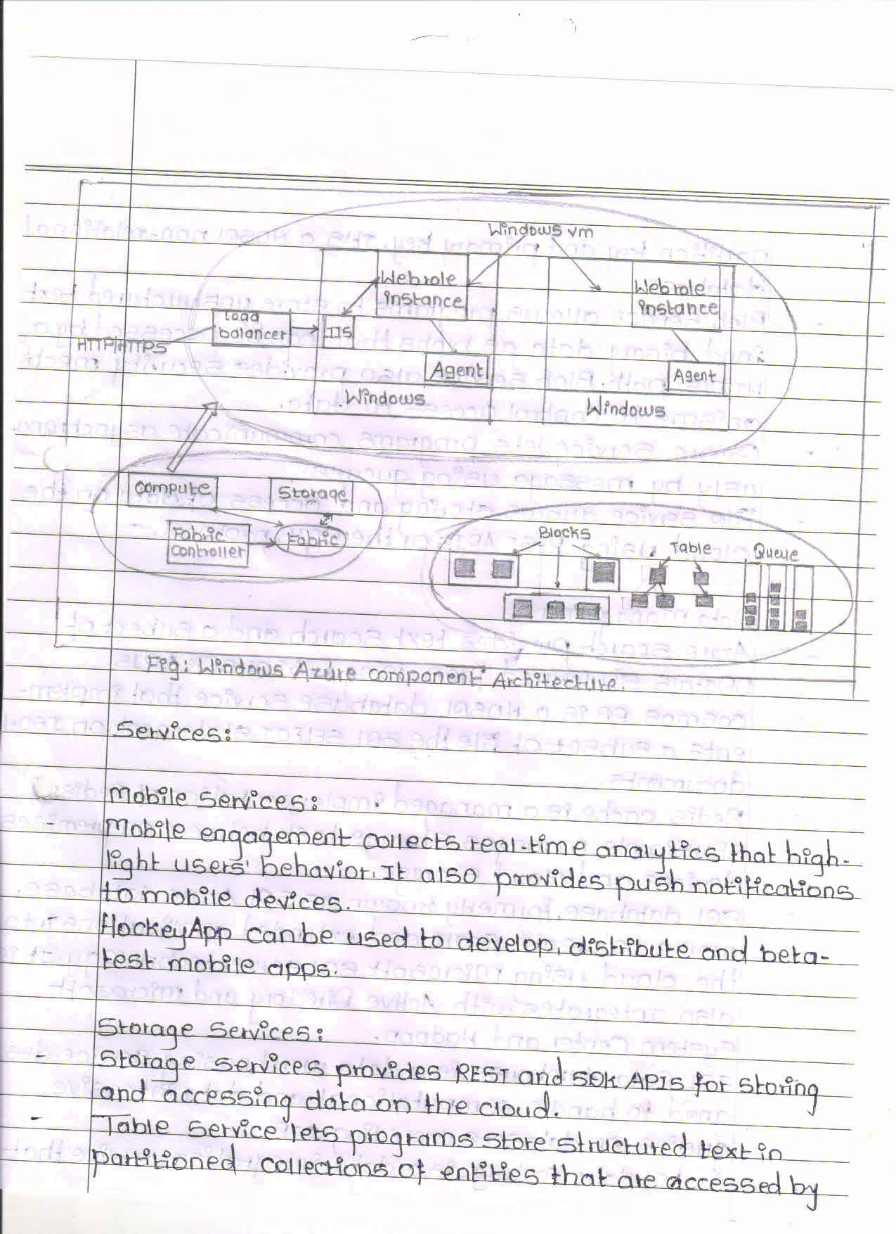****Diagram**

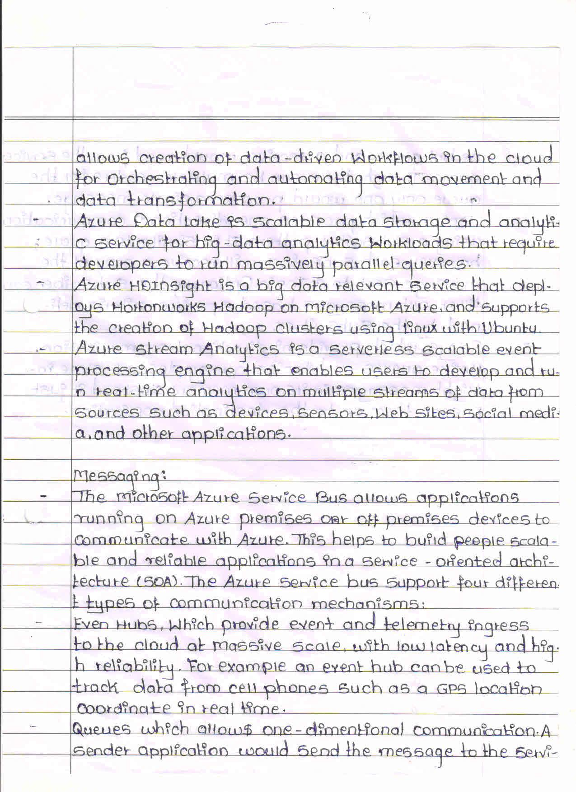

Conclusion –

Executing application in the cloud offer many advantages over the traditional way of running program.

Through this case study we learned about Microsoft Azure a cloud computing platform and infrastructure, created by Microsoft, studied about its features, services and data management techniques.

Many companies use Microsoft azure cloud services for their business.

Assignment - 2

Title – Google App Engine

Objective – to install and configure Google App Engine

Problem Statement – Installation and configure Google App Engine

Software and Hardware requirements –

Hardware – pc desktop/laptop with i5 processor and 4 gb ram

Software-

Operating system – LINUX

Google cloud software development kit

Python 2.7 or above

Theory –

Introduction

Google App Engine is a web application hosting service. an application or service accessed over the Web, usually with a web browser: storefronts with

shopping carts, social networking sites, multiplayer games, mobile applications, survey

applications, project management, collaboration, publishing, and all the other things we’re

discovering are good uses for the Web. App Engine can serve traditional website content too,

such as documents and images, but the environment is especially designed for real-time dynamic

applications

Google App Engine is designed to host applications with many simultaneous users. When an application can serve many simultaneous users without degrading

performance, we say it scales. Applications written for App Engine scale automatically. As more

people use the application, App Engine allocates more resources for the application and manages

the use of those resources. The application itself does not need to know anything about the

resources it is using.

Google App Engine:

It is a platform-as-a-service (PaaS) Cloud computing platform that is fully managed and

uses inbuilt services to run your apps. You can start development almost instantly after

downloading the software development kit (SDK). You can go on to the developer’s guide right

away when you click on the language you wish to develop your app in.

As soon as you have signed up for a Cloud account, you can build your app:

* With the template/HTML package in Go
* With Jinja2 and webapp2 in Python
* With Cloud SQL in PHP
* With Maven in Java

Generally Available Features

These are covered by the depreciation policy and the service-level agreement of the app engine.

Any changes made to such a feature are backward-compatible and implementation of such a

feature is usually stable. These include data storage, retrieval, and search; communications;

process management; computation; app configuration and management.

* Data storage, retrieval, and search include features such as HRD migration tool, Google Cloud SQL, logs, datastore, dedicated Memcache, blobstore, Memcache and search.
* Communications include features such as XMPP. channel, URL fetch, mail, and Google Cloud Endpoints.
* Process management includes features like scheduled tasks and task queue
* Computation includes images.
* App management and configuration cover app identity, users, capabilities, traffic splitting,

modules, SSL for custom domains, modules, remote access, and multitenancy.

Steps to install and configure google app engine:

1. Create a Google Cloud Platform project

2. Download google cloud SDK archive for your system depending upon the system os and architecture

3. Extract the archive to any location on your file system; preferably, your Home folder.

4. If you're having trouble getting the gcloud command to work, ensure your $PATH is defined appropriately. Use the install script to add Cloud SDK tools to your path. You will also be able to opt-in to command-completion for your bash shell and usage statistics collection during the installation process. Run the script using this command: ./google-cloud-sdk/install.sh

5. Restart your terminal for the changes to take effect.

6 Initialize the SDK

7 Use the gcloud init command to perform several common SDK setup tasks. These include authorizing the SDK tools to access Google Cloud Platform using your user account credentials and setting up the default SDK configuration.

8 Run core gcloud commands

Conclusion –

From the above lab practical we learned how to implement and configure google app engine using googles own google SDK and commands

Assignment - 3

Title – Apex programming Language application salesforce

Objective – to Create an Application using Apex programming Language in SalesForce.com

Problem Statement – Creating an Application in SalesForce.com using Apex programming Language

Software and Hardware requirements –

A computing device with a display having internet connectivity and capable to run web browser

Operating system – any

Web browser – any

Theory –

Introduction

What is Apex?

Apex is a proprietary language developed by the Salesforce.com. As per the official definition,

Apex is a strongly typed, object-oriented programming language that allows developers to

execute the flow and transaction control statements on the Force.com platform server in

conjunction with calls to the Force.com API.

It has a Java-like syntax and acts like database stored procedures. It enables the developers to

add business logic to most system events, including button clicks, related record updates, and

Visual force pages. Apex code can be initiated by Web service requests and from triggers on

objects. Apex is included in Performance Edition, Unlimited Edition, Enterprise Edition, and

Developer Edition.

Apex Applications

We can use Apex when we want to −

• Create Web services with integrating other systems.

• Create email services for email blast or email setup.

• Perform complex validation over multiple objects at the same time and also custom

validation implementation.

• Create complex business processes that are not supported by existing workflow

functionality or flows.

• Create custom transactional logic (logic that occurs over the entire transaction, not just

with a single record or object) like using the Database methods for updating the records.

• Perform some logic when a record is modified or modify the related object's record when

there is some event which has caused the trigger to fire.

Working Structure of Apex

As shown in the diagram below (Reference: Salesforce Developer Documentation), Apex runs

entirely on demand Force.com Platform

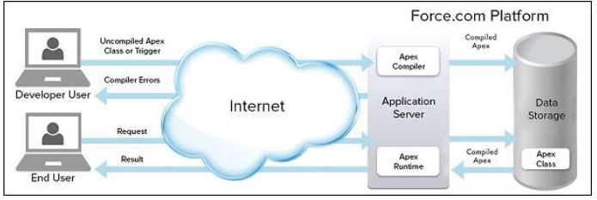

Flow of Actions

There are two sequence of actions when the developer saves the code and when an end user

performs some action which invokes the Apex code as shown below

Developer Action

When a developer writes and saves Apex code to the platform, the platform application server

first compiles the code into a set of instructions that can be understood by the Apex runtime

interpreter, and then saves those instructions as metadata.

End User Action

When an end-user triggers the execution of Apex, by clicking a button or accessing a

Visualforce page, the platform application server retrieves the compiled instructions from the

metadata and sends them through the runtime interpreter before returning the result. The end-user observes no differences in execution time as compared to the standard application platform

request.

Steps to create an Application in SalesForce.com using Apex programming Language\

1. Create new org: <https://developer.salesforce.com/signup>
2. After signup, logging using following URL <https://login.salesforce.com/>
3. Go to Developer Console for writing Program
4. Click on file then Select Apex class and write a code
5. Select tabs section (for creating GUI)
6. Open a pages
7. Write code in the Program Windows

Conclusion –

After performing the above lab practical we learned how to Create an Application in SalesForce.com using Apex programming Language and learned about apex architecture and its applications.

Assignment – 4

Title – Salesforce Cloud custom Application

Objective – to develop an Application using Salesforce Cloud

Problem Statement – Design and develop custom Application (Mini Project) using Salesforce Cloud

Software and Hardware requirements –

A computing device with a display having internet connectivity and capable to run web browser

Operating system – any

Web browser – any

Theory –

Introduction

Salesforce.com Inc. is an American cloud-based software company headquartered

in San Francisco, California. Though the bulk of its revenue comes from a customer relationship

management (CRM) product, Salesforce also sells a complementary suite of enterprise

applications focused on customer service, marketing automation, analytics and application

development.

Salesforce is the primary enterprise offering within the Salesforce platform. It provides

companies with an interface for case management and task management, and a system for

automatically routing and escalating important events. The Salesforce customer portal provides

customers the ability to track their own cases, includes a social networking plug-in that enables

the user to join the conversation about their company on social networking websites, provides

analytical tools and other services including email alert, Google search, and access to customers'

entitlement and contracts.

Lightning Platform

Lightning Platform (also known as Force.com) is a platform as a service (PaaS) that

allows developers to create add-on applications that integrate into the main Salesforce.com

application. These third-party applications are hosted on Salesforce.com's infrastructure.

Force.com applications are built using declarative tools, backed by Lightning and Apex

(a proprietary Java-like programming language for Force.com) and Lightning and Visual force (a

framework that includes an XML syntax typically used to generate HTML). The Force.com

platform typically receives three complete releases a year. As the platform is provided as a

service to its developers, every single development instance also receives all these updates.

Steps to Design and develop custom Application using Salesforce Cloud –

1. Click on Lightning Experience
2. Click on Setup and select Setup for current App.
3. Click on Create an Object
4. Click on Object Manager Tab next to Home Tab
5. Click on Create – Custom Object
6. New custom object page Open , Label as a-Comment, Plural label- comments
7. Give Record Name as –comment name, Data type- text
8. Select Allow Reports Check Box
9. Click on Save
10. Click on Home-Search Tabs in Quick search ,Select Custom Object-Click on New
11. For Object Select Comment, For Tab Style Select Any Icon
12. Click-Next-Next-Save
13. Search App Manager in Quick Search and select app manager
14. Enter name to app name, Click on Next-Next-Next.
15. Select Items (Contacts,Comment), Click on Next
16. Select Profiles ( System Administrator) and move to selected profile.
17. Click on Save and Finish.
18. Click on App Launcher Symbol and Select Comment Box App
19. Tour the app
20. Try out mobile app

* Select Chrome developer tools
* Open Chrome-Right Click on Chrome page
* Select Inspect
* Click Toggle Device Mode Button to simulate your browser as a mobile device

1. To simulate the sales force mobile app in your browser, copy and paste in url from previous tab.Delete the part of the url immediately.

* Click on Left navigation bar
* Find comment object under recent and click on it
* Click new to create a comment

Conclusion – After performing the above lab practical we learned how to Design and develop custom Application using Salesforce Cloud, we also learned about the salesforce lightning platform.